# Asa: 9:00-9:30 PM (20220803)

Birmingham, UK

25 years

Class vedio: <https://cloudarchives2.camblychina.com/62ea700d554c86afe1c0a112/4be326272546f8e7c9ec93a932197a82_cambly_62ea700d554c86afe1c0a112_0.mp4?auth_key=1659541074-7a5e4176133111ed9e3be24607df1fdb-0-9f0859f6ce3d3b3c23f9f4c730845f80>

**Get the negative feedback：**

1. Correct issues about my speak sentences
2. The next interview in 2 weeks. (~~after 2 weeks, I have the interview in the middle of August~~)
3. I am older than you ~~(I am bigger than you~~ , bigger = tall, height)
4. I am 1.8 meters tall (I am 180 centimeters ) . I grow taller than you.
5. ~~I climb the mountain.~~ We go to hiking at holiday.
6. I run less times because I injured my foot last year. (hurt)
7. I can touch the hoop/rim of the basketball.

7) My explosive power is not very good. (~~My explosive is my disadvantage~~)

8) The nutrition and do sports make young people grow more high taller.

9) I have many hobbies.

1. Sport topics (the endurance and explosive of your sport strength)

Patience, endurance, stamina

The marathon tests a runner's endurance.

I like long distance running.

1. Magic topic

1)Magic Trick (not only “magic” word)

Card, cube

2)texas hold'em: the kind of card play ( you need to bluff, and read other player face to guess their card )

~~3)I can show the hand trick.~~ (I can show the sleight of hand)

sleight of hand= type of trick using your hands

4) shin lim: the famous magician

5) Rubik’s cube

6) magic prop

(4) new vocabulary

|  |  |
| --- | --- |
| Tram | travel by tram (electric bus) |
| Vocabulary  adjective |  |
| Endurance | The marathon tests a runner’s endurance. |
| Explosive | short run can practice the explosive.  Explosive has the means as bomb |
| Sleight | adroitness in using the hands  I show the magic by the sleight with hands |
| Adroitness | skillful performance or ability without difficulty |
| Bluff | the act of bluff in poker; his bluff succeeded in getting him accepted  You need face people’s emotion and think the mathematics (card arrange)  (bluff )You need to say mistakes words in order to let people believe you have big, small cars |
| Hiking | a long walk usually for exercise or pleasure |
| Adjective:adj |  |
| Note / message |  |
| factor |  |
|  | forgot / forgive |

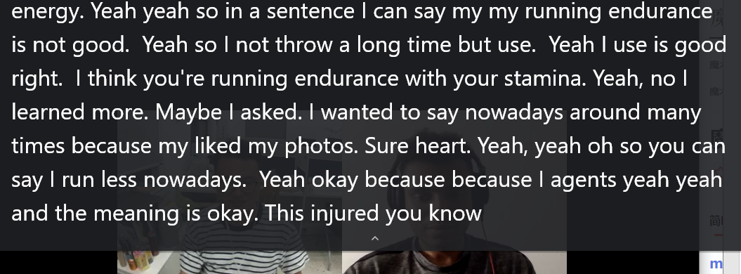

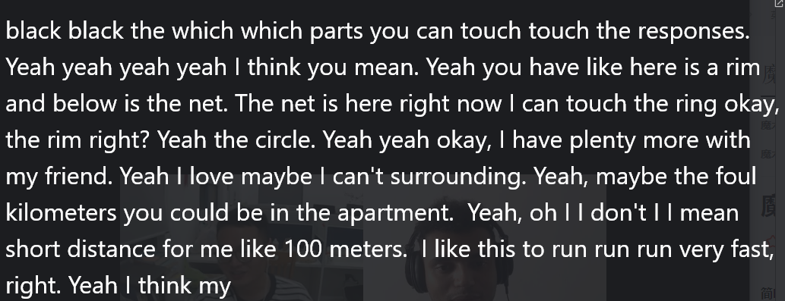

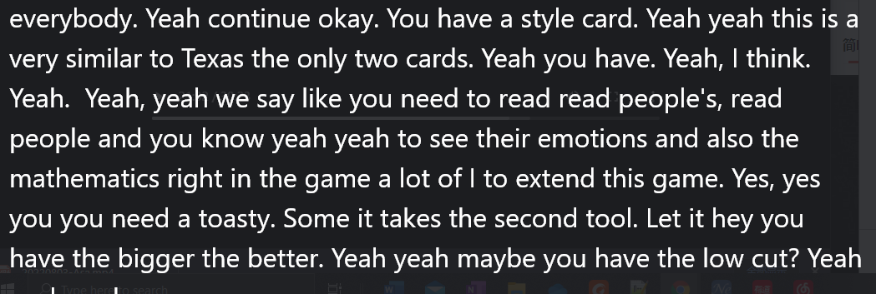

**Chatting:**

Tram 电车

the next interview is in 2 weeks

side income

older

I am older than you

bigger = tall, height

endurance, stamina耐力

energy

My running endurance is not good.

I run less nowadays because I injured my foot last year.

injured

rim

100m

My explosive power isn't very good.

explosive (adjective)

explosive (noun)

形容词

explosive = something you use to destroy things

The army use explosives to kill people.

bomb

180cm

o grow taller

poker

texas hold'em

read people

bluff

sleight of hand

= type of trick using your hands

algorithm

The props cube

shin lim

climbing the mountain

hiking up mountains

# Daniel: 9:00-9:30 PM (20220803)

1. 基本音标问题
2. 我的耳机有问题，杂音很重，需要换一个好一点的耳机。如果到正式面试，要确保网速，摄像头和耳麦都正常工作，否则对影响面试质量。

买了一个耳机

Daniel带我练习了英文版的绕口令，一句话就卡主了。

需要练习音标

a, e, i, o u

Daniel：英语有很多单词，当他看到新的单词，他通过音标和元音来读他

方法：在哔站找到练习音标的链接。

<https://search.bilibili.com/all?keyword=%E8%8B%B1%E8%AF%AD%E9%9F%B3%E6%A0%87&from_source=webtop_search&spm_id_from=333.1007>

# Daniel: 10:00-10:30 PM (20220804)



Lesson:

Practice the reading question and answer question.

Suggestion:

1. Answer the question need to simple.

For example: Question and Answers.

Q: Do you think your country people do enough exercise? /ˈeksəsaɪz/

A: I do not think our country people do enough exercise because they work long hours or study long hours.

~~In my country, many people work too long hours or study too long hours, they need to relax firstly, they choose to play computer games or watch the short video.~~

~~You are too complicated again, be less complicated okay. You should say simply.~~

Q: Do you think children should play some sports after school?

A: I think children should play some sports because it keeps children strong and healthy (energetic)

Q: Do you like any sports? Why?

A: I like playing basketball, I like the feeling (the best experience is ) when I scored the winning basket.

Q: Do you think children should do the competitional sports at the early age?

A: Yes, I think children should do that because the competitional sports make them study the team work.

Injured / hurt

Q: Do you think sports as a career or as a fun?

I think less people can become the Professional sporter.

Most people do sports keep them strong and health.

1. I will be nervous when I speak the new/unknown sentences.

Daniel says the fear is the killer. I need to study the relax.

1. The dog is the loyal friend of people, it gives his master the unconditional love.
2. I played basketball one hour ago. My throat is dry (dehydration, /ˌdiːhaɪˈdreɪʃ(ə)n/, 脱水), I need to drink much water.
3. Image /ˈɪmɪdʒ/ imagine /ɪˈmædʒɪn/想象
4. I have a hundred percent sure you can do it much better.
5. All mistakes are good for study a new thing. That’s part of learning. If you are not making mistakes, you are not learning. In other words, negative feedback.

Grammer: don’t and does’t to make negative sentences

Border collie 边境牧羊犬and maramano

Scenarios /səˈnɑːriəʊz/ 情节

Verb /vɜːb/ 动词

The sibling /ˈsɪblɪŋ/ (brothers and sisters) twins are so similar because they have the same DNA.



